No Cell Phones
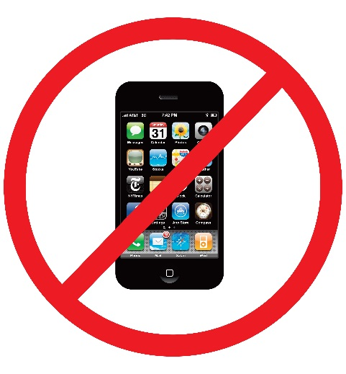

Our policy on the Steam team is that students will place their cell phones in the “Cell Phone Jail” at the front of the classroom immediately upon arrival.
There will be no exceptions. If a students is caught with a cell phone during class time, the teacher will confiscate the phone and it will be returned to the student at the end of the day. If the student has a cell phone taken three times, the parents will have to pick up the cell phone from the Assistant Principal and a referral will be made.
In the event that student devices are needed for classwork, students will be given their devices from the “Cell Phone Jail” at the appropriate time.
Thank you for your cooperation in this matter!

