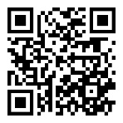C:\Users\emoore\AppData\Local\Microsoft\Windows\Temporary Internet Files\Content.IE5\G46ZJMU3\MC900187587[1].wmfTeam 8-2 STEAM Team

Website-<http://mmsteam82.weebly.com>

Email-[mmsteam82@gmail.com](mailto:mmsteam82@gmail.com)

518-483-7801

Scan our QR Code

Welcome to Team 8-2! We hope you are ready for an exciting school year. You have been hired as part of our STEAM team. We will collaborate this year to achieve greatness. Our team’s vision is to be an exemplary 21st Century learning community whose graduates are prepared to excel in a complex, interconnected, changing world.

**We believe that:**

GRIT matters most.

Each individual has dignity and worth.

Curiosity and exploration stimulate innovation and learning.

Effort and perseverance are essential to achieve one's personal best. High expectations and challenging curriculum lead to greater achievement.

Collaboration within and among school, families, and community partners is essential to meet the needs of each student.

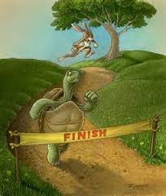

**Our expectations are:**

Employee Expectations:

GRIT Matters

THINK before you speak

Bring your SOFT skills

Performance Expectations:

No late homework will be taken unless prior arrangements have been made

Major projects turned in late will lose points at a rate of 10 points per day

Be punctual and prepared

**Supplies:**

Calculator (TI 30XIIs) or TI30 App (available for Android and Iphone)

One 4-5 Inch Binder

Dividers with pockets (for Binder)

3 Hole Pencil Case (for Binder)

Inexpensive Head Phones/ Earbuds (available at the Dollar Store)

Pens / Pencils /Highlighters

4-5 packs of Loose Leaf Paper (for Binder)

Please visit our website for more information and complete the Parent Response Form. As an alternative, you may also complete the bottom of this letter.

­­­­­­­­­­­­­­­­­­­­----------------------------------------------------------------------------------------------------------------------------------------------------------------------------------------------------------------------------------------------

I have read this letter and have discussed it with my parent.

Parent/Guardian Signature: __________________________________________________________________Date: _______________________

Parent/Guardian Email: ___________________________________________________________________________________________________

Student Signature: __________________________________________________________________________Date: ________________________